# ***Project development Phase***

# Model Performance Test

|  |  |
| --- | --- |
| Date | 28 June 2025 |
| Team ID | LTVIP2025TMID41229 |
| Project Name | ***Smart Sorting Using Transfer Learning for Identifying Rotten Fruits and Vegetables*** |
| Maximum Marks | 10 Marks |

|  |  |  |  |
| --- | --- | --- | --- |
| **S.No** | **parameter** | **values** | **screenshot** |
| **1.** | Metrics | **Regression Model:** MAE- , MSE-,  RMSE- , R2 score  **Classification Model**:  Confusion Matrix, Accuracy score, &Classification Report |  |
| **2.** | Tune the model | **Hyperparameter tuning-** **Validation Method -** |  |

## **🍎 Overview**

### ***A Machine Learning-Based Quality Detection System***

*Smart Sorting Using Transfer Learning for Identifying Rotten Fruits and Vegetables* is a web-based system that detects whether fruits and vegetables are fresh or rotten using advanced machine learning techniques. It leverages transfer learning models like TensorFlow/Keras to classify images of produce, helping users and businesses ensure food quality and reduce waste.

## **💡 Project Title**

***Smart Sorting Using Transfer Learning for Identifying Rotten Fruits and Vegetables***

## **⚙ Tech Stack**

|  |  |
| --- | --- |
| **Layer** | **Technology Used** |
| *Frontend* | HTML, CSS |
| *Backend* | Python (Flask) |
| *ML Model* | TensorFlow / Keras |
| *Styling* | Custom CSS |

## **✨ Features**

### **🔍 User Features**

* Upload images of fruits and vegetables
* Get real-time classification result: Fresh or Rotten
* Confidence score for each prediction
* Educational tips on storing produce
* Contact form for feedback or queries

### **👤 Admin Features**

* Dashboard with upload statistics and prediction trends
* Manage uploaded images and results
* Export data for analysis
* Retrain/update model with new datasets

## **📁 Folder Structure**

Project-root/

├── dataset/

│ └── fruit-and-vegetable-data/

├── output_dataset

├── static/

│ ├── css/

│ │ └── style.css

│ ├── image/

├── templates/

│ ├── index.html

│ ├── about.html

│ ├── predict.html

│ ├── contact.html

│ ├── login.html

│ └── register.html

├── uploads/

├── app.py

├── rotten_detector.ipynb

├── readme.txt

└── requirements.txt

## **🖥 Frontend Details**

|  |  |
| --- | --- |
| **Page** | **Description** |
| index.html | Landing page with introduction and "Upload" button |
| about.html | Information about the project and team |
| predict.html | Image upload and result display |
| contact.html | Form for user feedback or support requests |

## **🏗 Backend Details**

### **Key Routes:**

* /register – Creates an account page
* /login- Login page to access the home page
* /index – Home page
* /about – About page
* /predict – Image upload and prediction endpoint
* /contact – Form submission handler

### **Key Files:**

* **app.py**: Main Flask application handling routes, image processing, and predictions.
* **rotten_detector.ipynb**: Jupyter Notebook containing the code for model training and testing.

## **🛢 Dataset**

The dataset consists of categorized images of fruits and vegetables:

* *Fresh Produce*
* *Rotten Produce*

Includes various types such as apples, bananas, tomatoes, etc., in different lighting conditions and angles.

Dataset Link : https://www.kaggle.com/datasets/muhammad0subhan/fruit-and-vegetable-disease-healthy-vs-rotten

### **Preprocessing Steps:**

* Resizing images to uniform dimensions
* Normalization of pixel values
* Train-test-validation split
* Augmentation (optional for better accuracy)

## **📸 Screenshots**

1. *Create an Account Page* –User must create an account to access home page
2. *Login Page* – If user has an account, he must login to access home page
3. *Home Page* – Welcome message and upload button
4. *About Page* – Project details and team information
5. *Prediction Page* – Upload form and result display
6. *Contact Page* – Feedback form

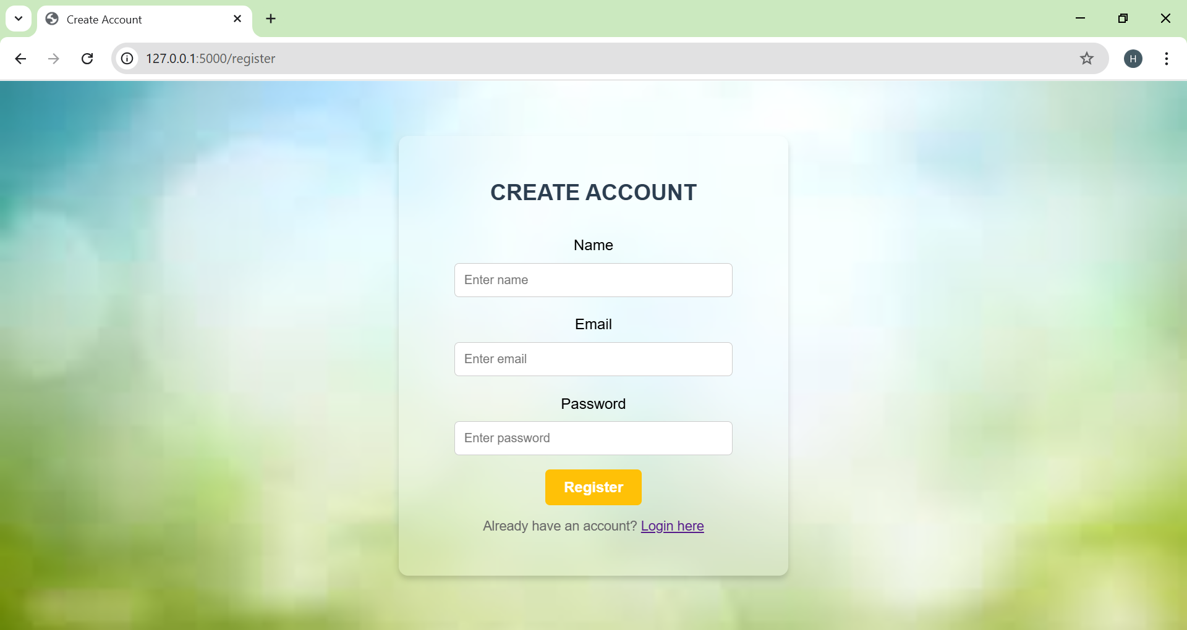

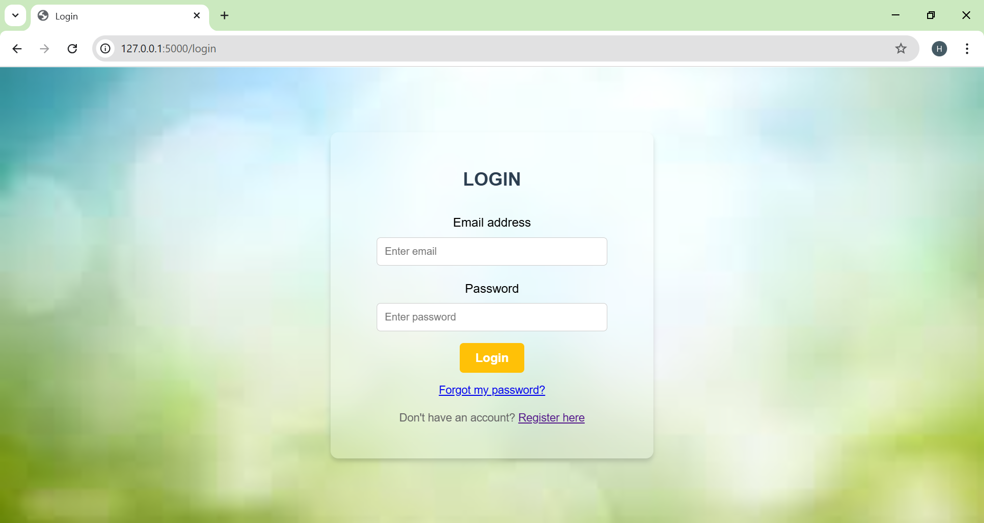

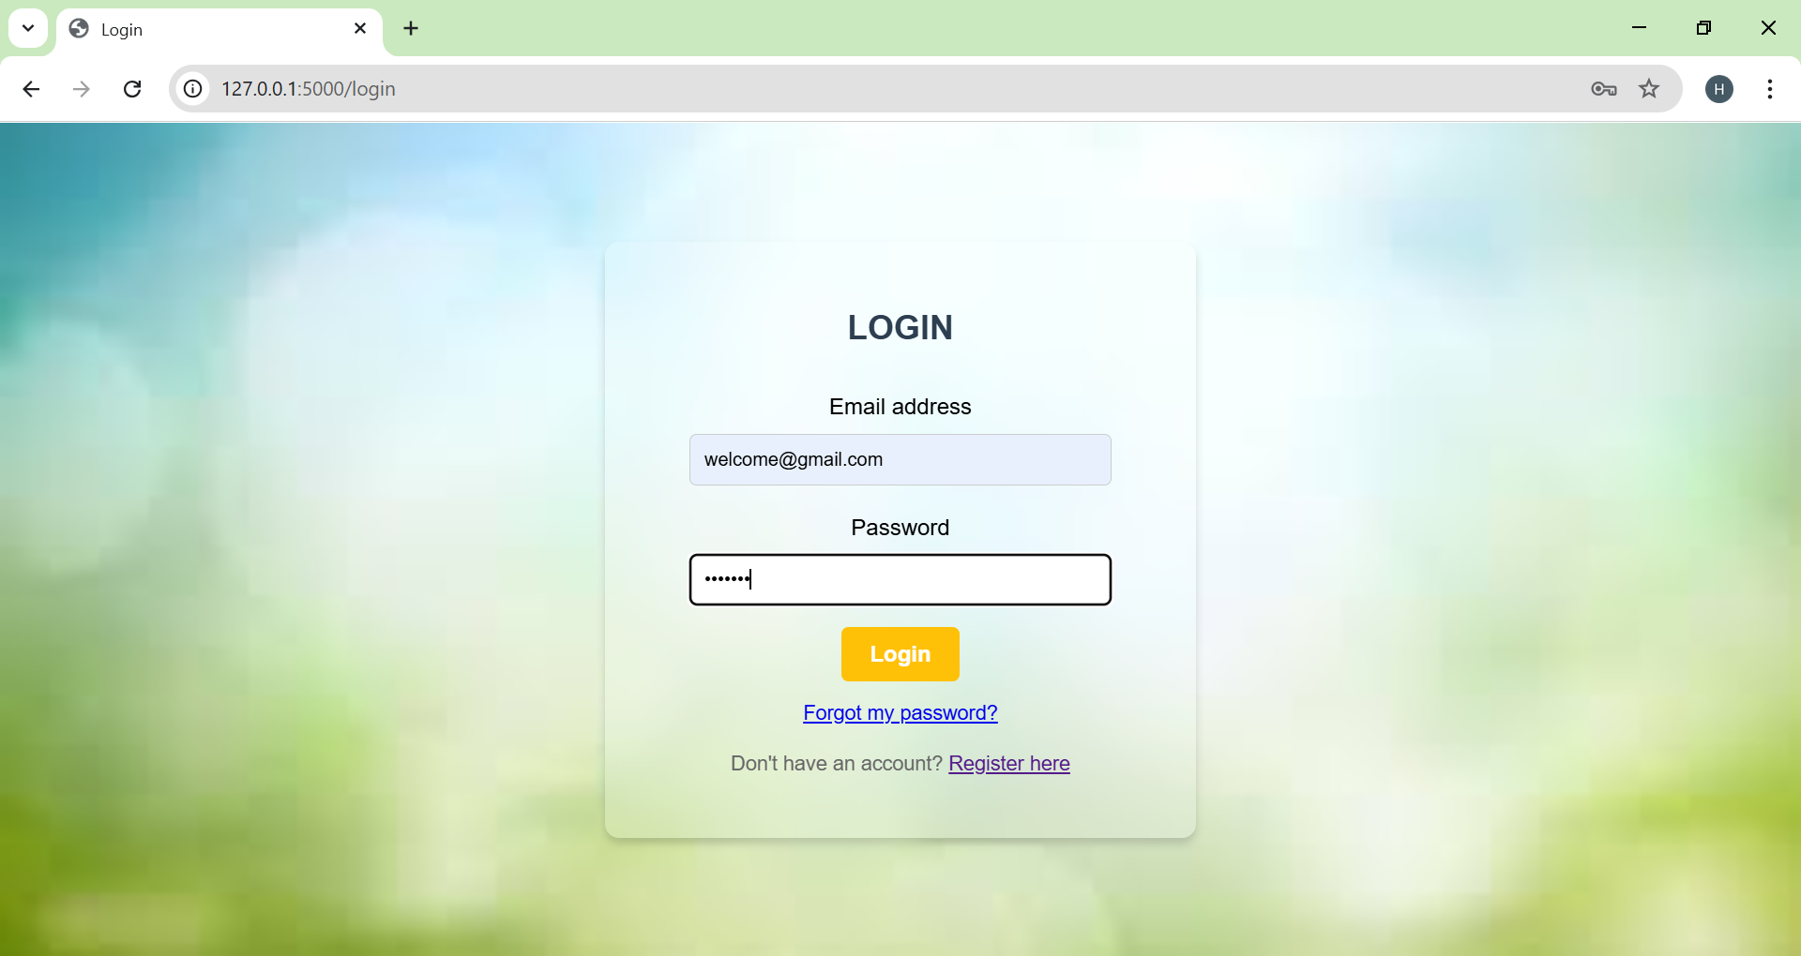

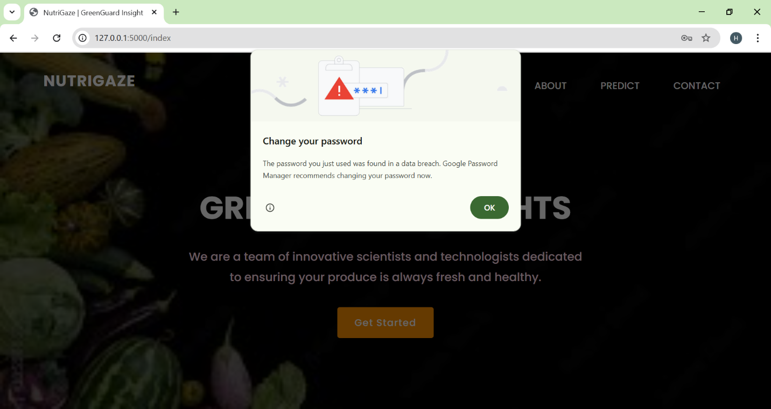

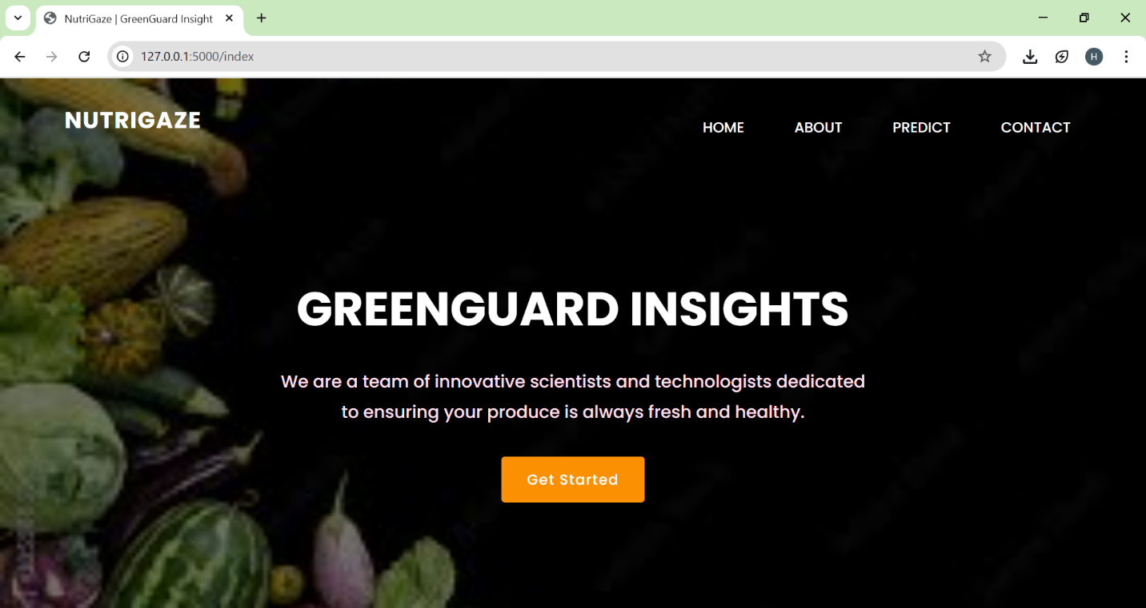

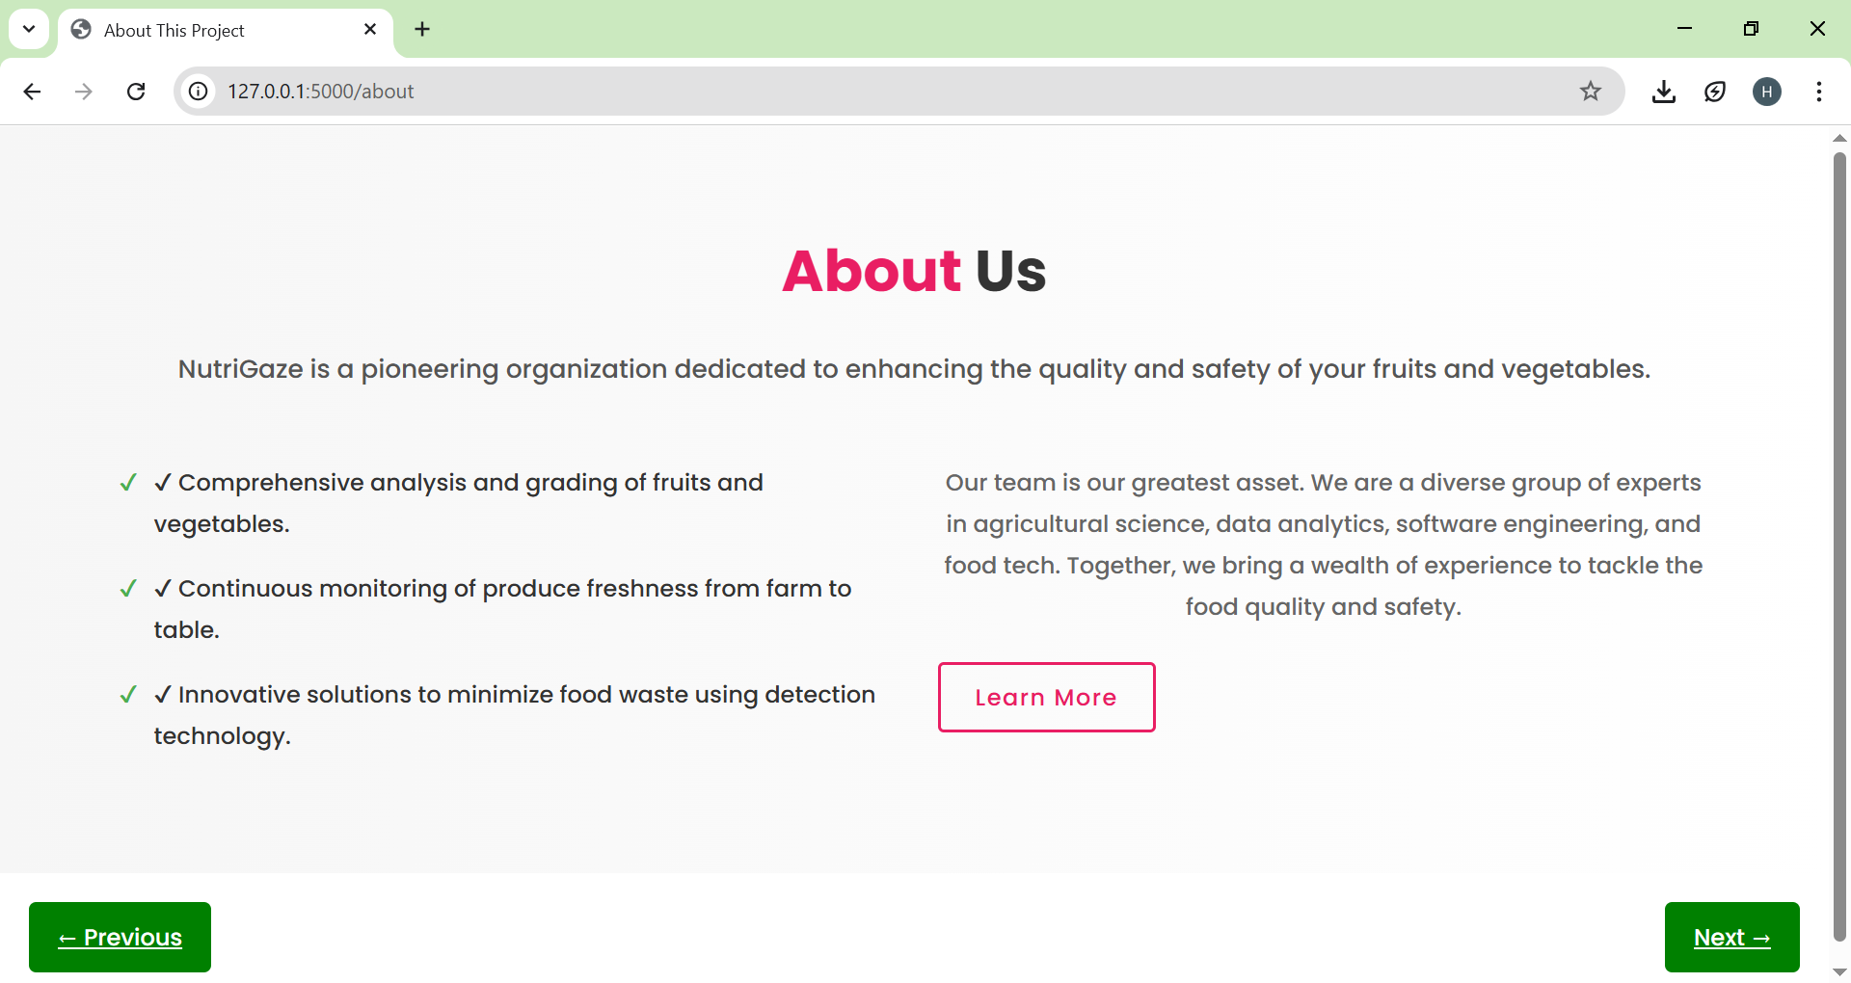

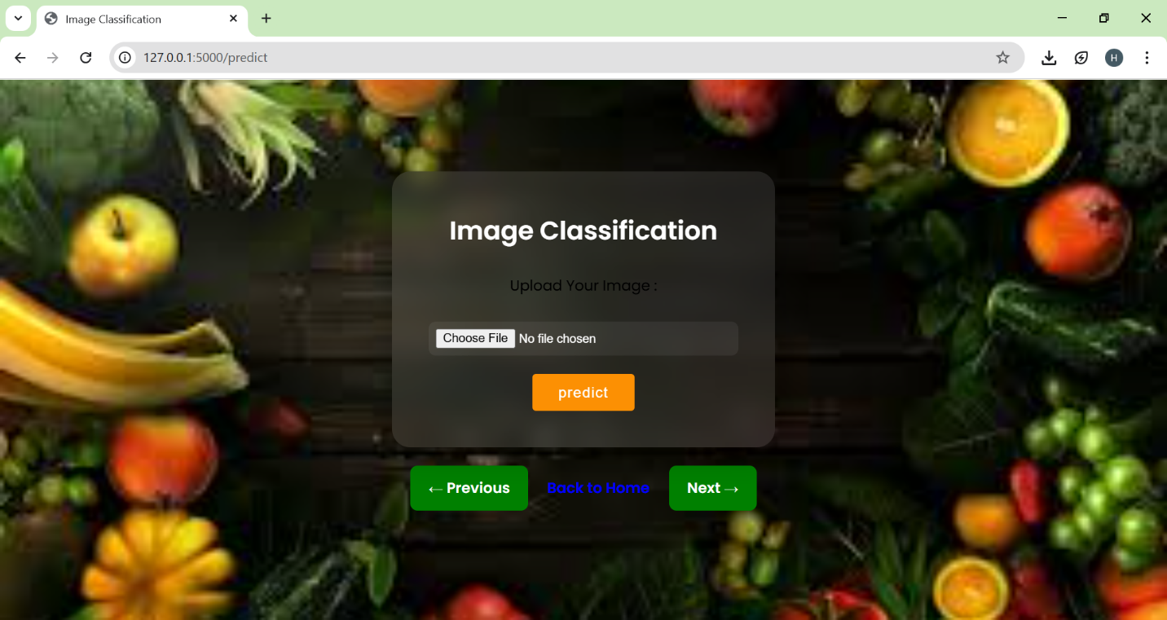

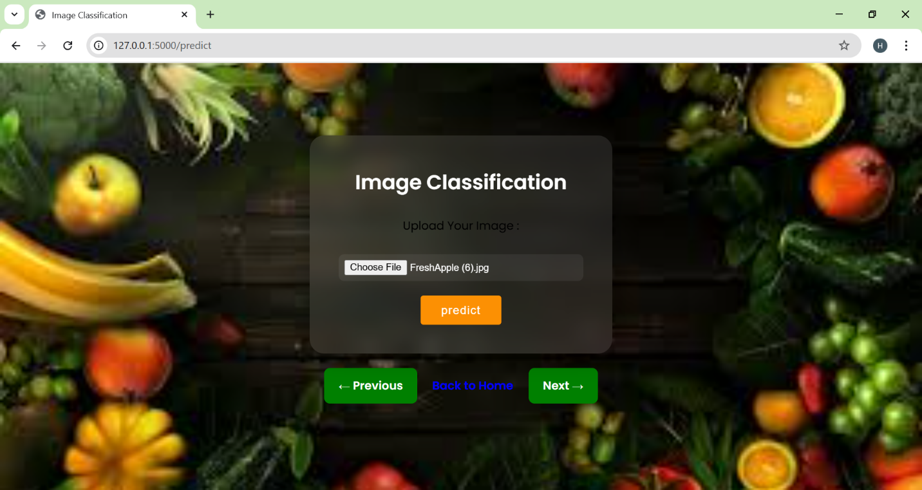

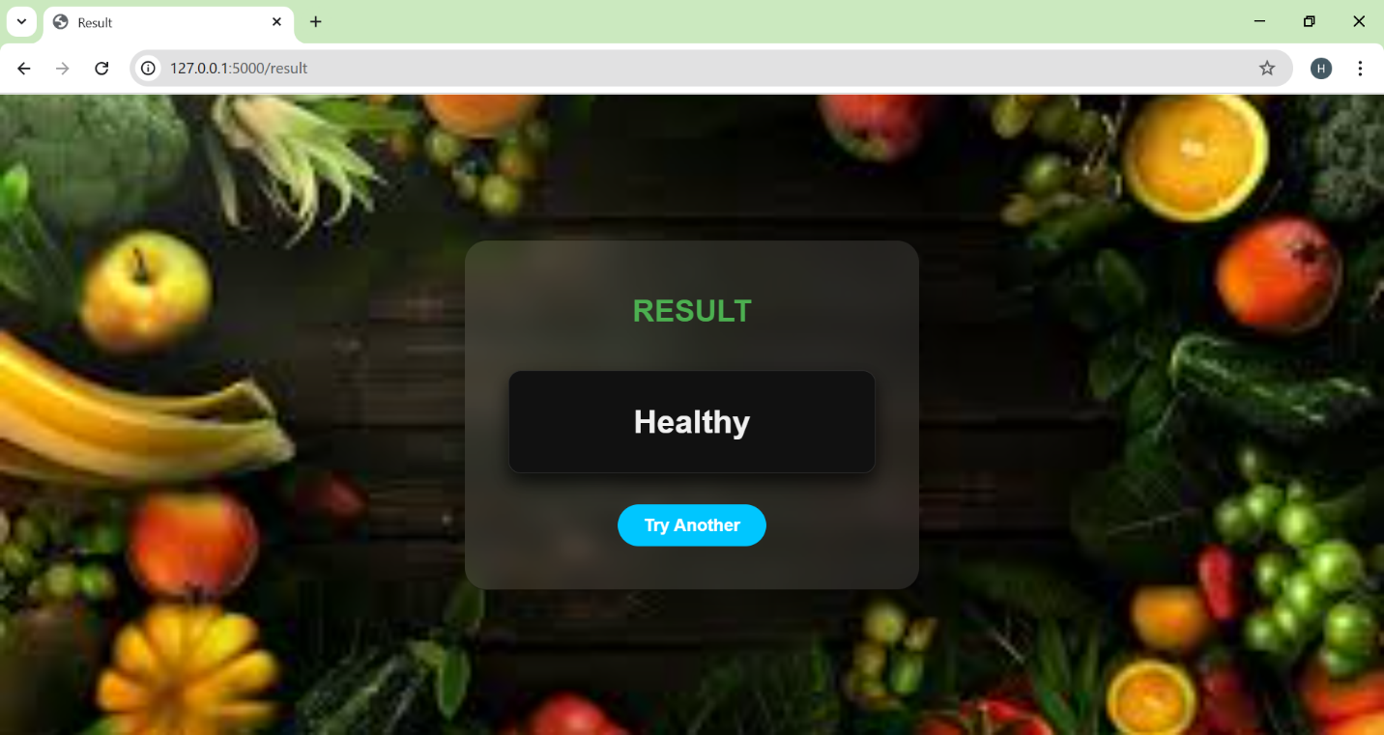

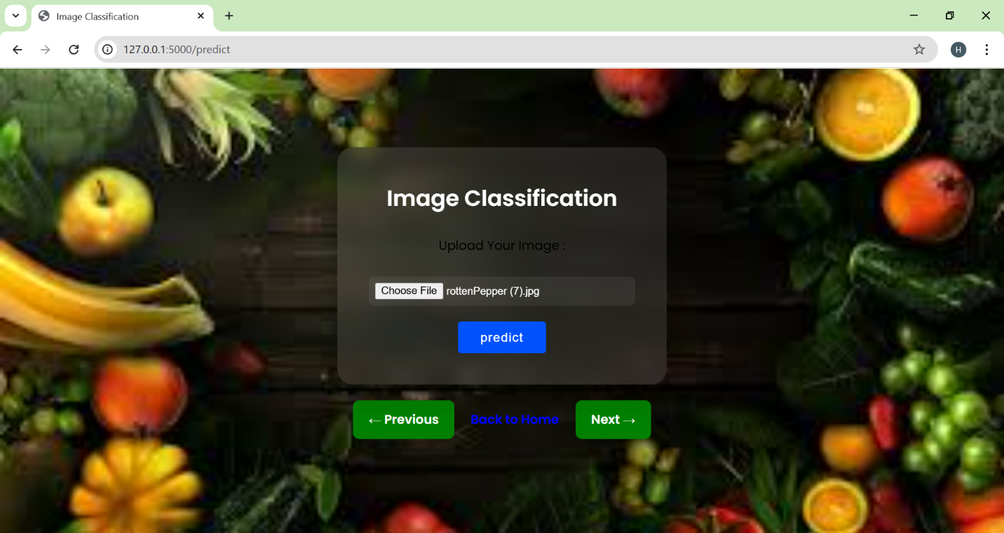

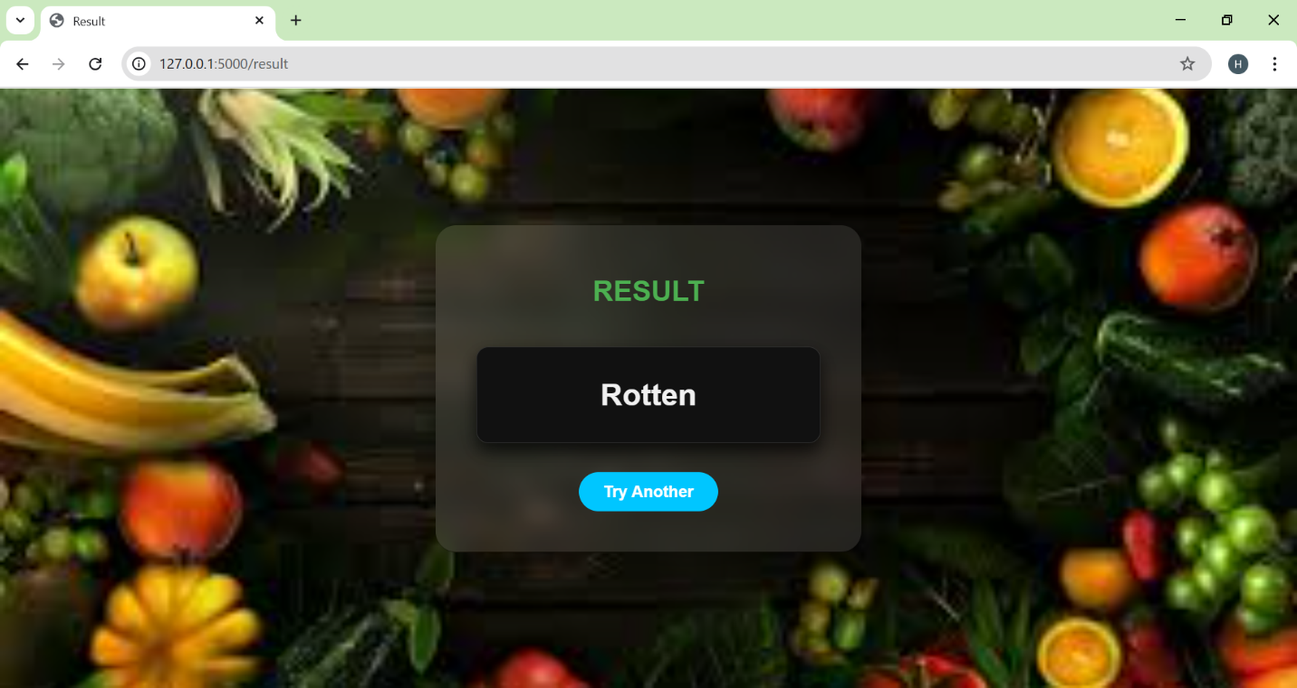

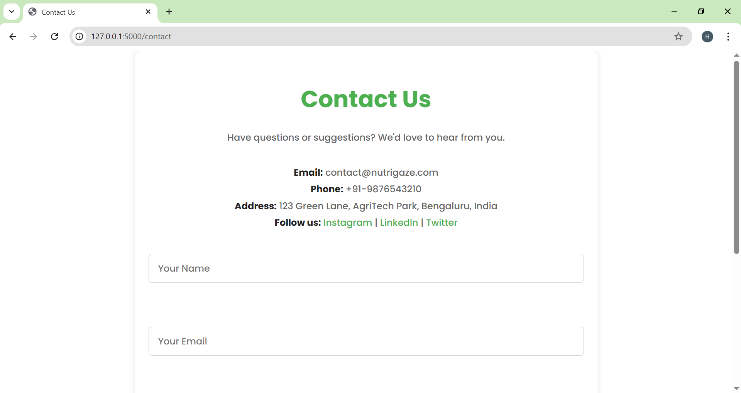

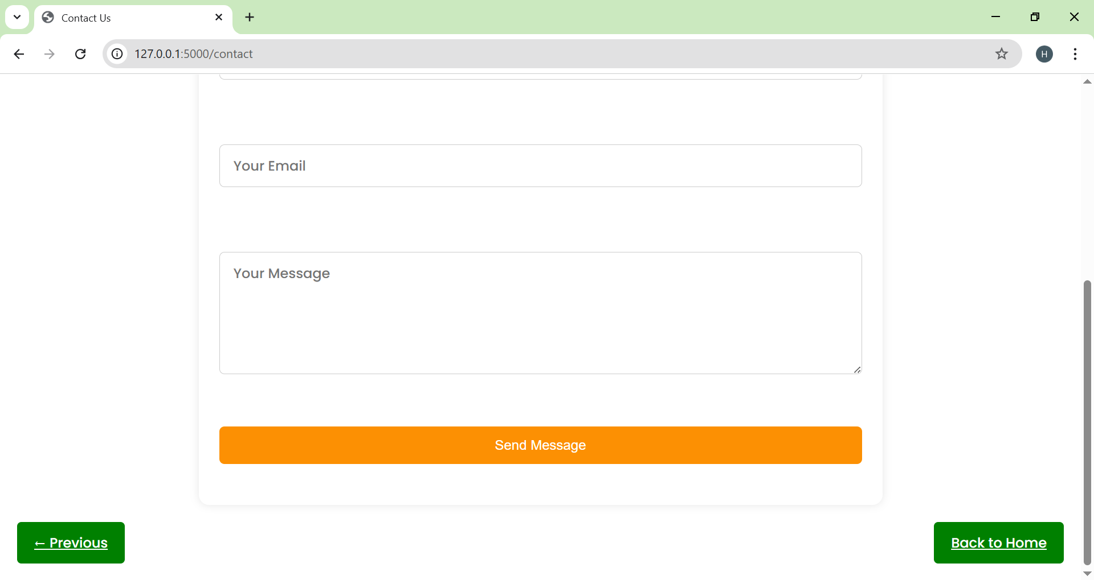

## **▶ Demo Instructions**

### **Step-by-step Setup:**

1. *Set Up Environment Variables (if any)*
   1. Create. env if needed (for future enhancements like email alerts)
2. *Install Dependencies* bash pip installs flask tensorflow numpy pillow
3. *Run Locally* bash python app.py
4. *Open Application*
   1. Navigate to [http://localhost:5000](http://localhost:5000/) in your browser

## **🔮 Future Improvements**

* *Enhanced Accuracy* – Use more diverse and larger datasets
* *Mobile App Integration* – Build an Android/iOS app for portability
* *IoT Integration* – Real-time monitoring systems in storage units
* *Multi-Language Support* – Make it accessible globally
* *Advanced Analytics* – Provide detailed insights on spoilage trends

## **👥 Contributors**

* **Puchalapalli Harshitha**
* **Guntagani Pravallika**
* **Modaboyana Lavanya**
* **Sangaraju Poojitha**

✅ *End of Documentation*

This document serves as a complete reference guide for the Smart Sorting project, covering its architecture, features, tech stack, deployment instructions, and scope for future development.